While watching the Classification of living things, answer the following questions:

- Who began classifying organisms and in what year?

- What are the three domains that we use to classify living things in the present? Look up the definition of each of these domains and list them below.

  - ___________________: ____________________________________________________________

  - ____________________: ___________________________________________________________

  - ____________________: ___________________________________________________________

- What idea do we (scientists) build our whole naming system around?

- What was the problem with the way Linneus classified living things?

- What does convergently evolved mean?

- Instead of looking at the physical similarities of organisms, what do we now use to help us determine how closely related organisms are?

- Which two classifications are all living things named in Binomial Nomenclature or the scientific name?

- List in order the 8 categories of how we classify life on Earth.
  - ___________________
  - ___________________
  - ___________________
  - ___________________
  - ___________________
  - ___________________
  - ___________________
  - ___________________

- What is a good way to remember their order?

Assignment: You will create a taxonomy foldable for an organism of your choice.
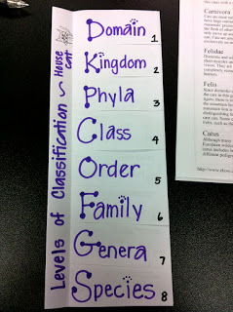
Grab a sheet of paper!
- Fold in half - Hot Dog Style
- Place one finger on the paper and fold your top flap back... up to your fingertip. This will leave a small unfolded/uncut section for your title. You can see in the pic to the left - this section is where you put your title!

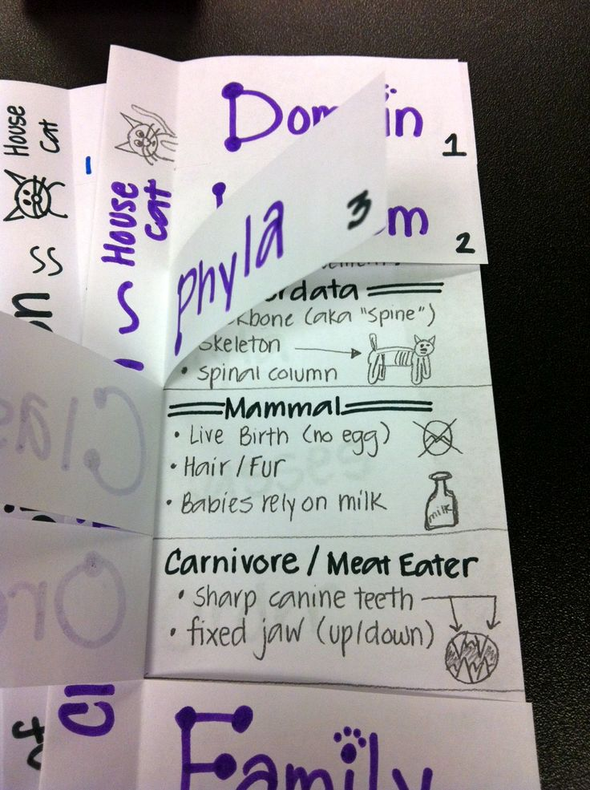
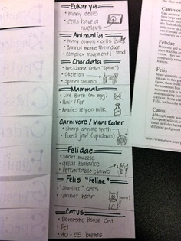
3. Cut! In half, in half again and so on, until you have four bottom flaps. Then repeat to the top section.

