Darwin’s Great Voyage of Discovery
adapted from Excerpts from Charles Darwin’s Voyage of the Beagle

It is the year 1831 and you have just been hired to accompany a young environmentalist by the name of Charles Darwin on an expedition around the world! You have created journal entries recording experiences of your great expedition.
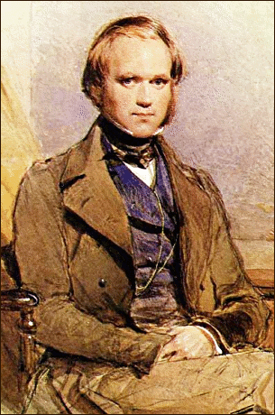
Preface (Words from Charles Darwin himself)
I have stated in the preface to the first Edition of this work, and in the Zoology of the Voyage of the Beagle, that it was in consequence of a wish expressed by Captain Fitz Roy, of having some scientific person on board, accompanied by an offer from him giving up part of his own accommodations, that I volunteered my services, which received, through the kindness of the hydrographer. I hope I may be able to repeat my expression of gratitude to him; and to add that, during the five years we were together, I received from him the most cordial friendship and steady assistance. Both Captain Fitz Roy and to all the Officers of the Beagle. I shall ever feel most thankful for the undeviating kindness with which I was treated during our long voyage.....

As we move from stop to stop throughout our voyage, Mr. Darwin does the same while keeping detailed records and collecting an enormous number of specimens. He tries to explain to that he believes that the species that look similar evolved from a common ancestor, but evolved differently due to different needs in their respective environments.
Mr. Darwin would later propose that, through a process he called Natural Selection, members of a species that are best suited to their environment survive and reproduce at a higher rate than other members of the species. Mr. Darwin based his idea of natural selection on a few key principles:
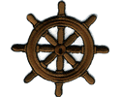Overproduction Variation Adaptation Selection

Is Charles Darwin correct? I decide to begin taking my own notes on the same organisms that Mr. Darwin observes. As we travel from stop to stop with the HMS Beagle, I will answer questions that I ponder on a log sheet to see if there is any validity to what Mr. Darwin is proposing!

In order for me to complete my log detailing Charles Darwin's observations, we will first circumnavigate the globe and see what sparked the soon-to-be-famous evolutionary biologist's theories of evolution by natural selection.

After embarking on our first voyage from port of England, I will continue recording observations on the log sheet at the following locations along the route of the HMS Beagle:
Santiago - one of the Cape Verde Islands off the northwestern coast of Africa

Salvador - port city on the east coast of South America, in present-day Brazil

Galapagos Islands - 22 islands located off the west coast of South America, near present-day Ecuador

Australia - island continent located across the Pacific Ocean, bordering the Indian Ocean on its western coast

St. Helena - island located off the southwestern coast of Africa

Devonport, England: 50ºN 4ºW
December 27, 1831
As we set sail on the British Royal Navy ship The HMS Beagle, I join the crew on their journey to chart the South American coastline.
The gentleman that I will accompany will require me to be by his side throughout the duration of the trip – I will carry his bags, share his living quarters, retrieve food and water for him, and, in turn, I will see the world through his eyes on this voyage.
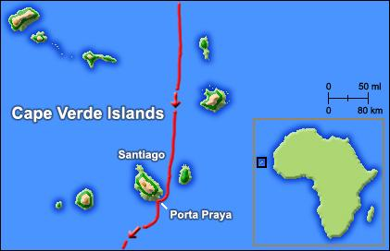
Santiago
Cape Verde, Porto Praya: 14ºN 23ºW
January 16, 1832

After making stops first at the Madeira and Canary Islands, the HMS Beagle dropped anchor at the Cape Verde port of Porto Praya, on the island of Santiago, on January 16, 1832. I realize that Charles Darwin is not just any young environmentalist. I note that Mr. Darwin is observing the variety of species found at the location and makes notes about what he refers to as his "principles" that govern the survival or evolution of species.
I am very eager to explore the tropical island, but can only do so at the heals of the gentleman whom I were hired to accompany, Mr. Charles Darwin. Luckily, I find that Mr. Darwin likes to explore more than I do, and we are quickly off examining the landscape, as well as the plants and animals that live there.
On one of our many excursions, Mr. Darwin was lucky enough to observe a clownfish lay thousands of her precious eggs in the tropical Atlantic Ocean. Why thousands??
Mr. Darwin explains to you his principle of overproduction - when a plant or animal produces more offspring than can possibly survive in nature. He continues to explain that of the thousands of eggs produced, only a few hundred will actually hatch and to become prawn (baby fish). Of those few hundred that hatch, several dozen will live to adulthood. An even smaller number will successfully reproduce.
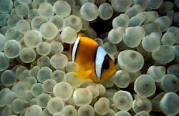

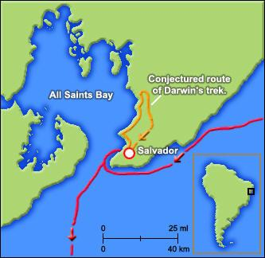
Salvador
Salvador Brazil 13oS 38oW
February 28, 1832

The HMS Beagle arrived in Salvador, Brazil on February 28, 1832. The crew spent two and a half weeks anchored in All Saints Bay, and it was during this time that you are able to explore Brazil's tropical rainforests with Charles Darwin.
As you travel throughout the rainforest with Darwin, you find it odd that you don't notice something - insects! Darwin points out to you that they are there, you just have to look closer. You take a better look, and notice that many insects have an adaptation that
enables them to blend in with their background....camouflage!

Rio de Janeiro, Brazil: 23oS 43oW
July 5, 1832
In the morning we got underway, and saw a great shoal of porpoises, in fact many
hundreds in number. As we continued our Journey into the Plata we were then surrounded by numerous seals and penguins, which made such strange noises, that the officer on watch reported he could hear the cattle bellowing on shore. On the second night we witnessed such a splendid scene of natural fireworks; the mast-head and yard-arm-ends shone with St. Elmo’s light; the tracks of the penguins were marked by a fiery wake, and the darkness of the sky was momentarily illuminated by the most vivid lightning.

Tierra del Fuego, Argentina: 55oS 73oW
December 17, 1832
Having now finished with Patagonia and the Falkland Islands, I will describe our first arrival in tierra del Fuego. We kept close to the Fuegan shore, but the outline of the rugged, inhospitable land was amidst the clouds. In the afternoon we anchored in the Bay of Good Success.The harbour consists of a fine piece of water half surrounded by low rounded mountains of clay, which are covered to the water’s edge by the dense gloomy forest. A single glance at the landscape was sufficient to show me how widely different it was from anything i had ever beheld. At night it blew a gale of wind, and heavy squalls from the mountains swept past us. It would have been a bad time out at sea, and we, as well asothers, may call this Good Success. Bay...
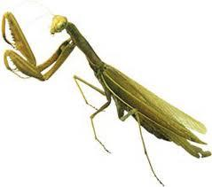
In line with text | Fixed position

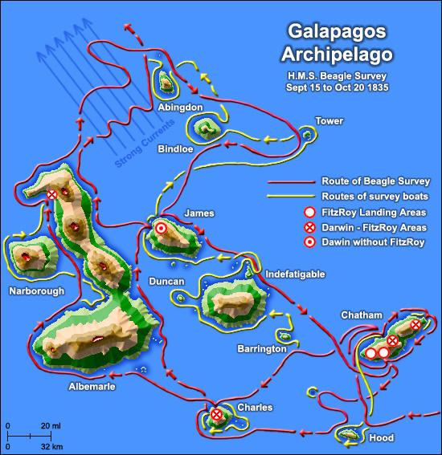
Galapagos Islands
22 islands located off the west coast
of South America, near present-day Ecuador
Galapagos, Islands: 0oS 90oW
September 15, 1835

After setting sail from Callao, Peru on September 7, 1835, Charles Darwin and I, first laid eyes on the Galapagos Archipelago eight days later. The islands themselves were fairly uninhabited by humans, 10 total, though one of the islands to the south, Charles Island, was populated by a small colony of 250 political prisoners from nearby Ecuador. The islands are all formed from volcanic rocks: a few fragments of granite curiously glazed and altered by the heat, can hardly be considered the exception. It is on this string of islands that you watch Mr. Darwin make some of his most well-known observations that led to his theory of evolution by natural selection.
During your 35 day stay among the 22 islands off the west coast of South America, you join Charles Darwin in studying many native species of plants and animals. Among those that you study are iguanas, snakes and tortoises (one Englishman in charge of the prison
colony remarked to Mr. Darwin that he could tell which island a tortoise came from by
looking at the shape of its shell and they differed from island to island). The rocks on the
coast abounded with great black lizards, between three and four feet long; and on the hills, an ugly yellowish-brown species was equally common.
However, the most memorable of all of Mr. Darwin's subjects are the thirteen species of
finches that he saw living throughout the Galapagos Islands. Mr. Darwin was particularly
fascinated by the differences in beak shape that he noted amongst the similar-looking
birds.
Why do the finches have differently shaped beaks?
How can birds that live on different islands look so similar, yet be different?
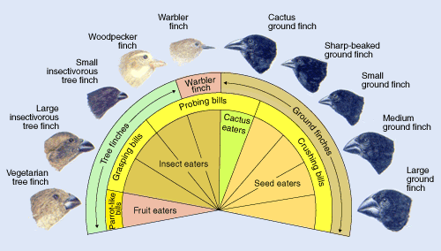

Tahiti Island, French Polynesia: 17oS 149oW
November 15, 1835
At daylight, Tahiti, an island which must forever remain classical to the voyager in the South Sea,
was in view. At a distance the appearance was not attractive. The luxuriant vegetation of the
lower part could not yet be seen, and as soon as the clouds rolled past, the wildest and most
precipitous peaks, showed themselves toward the centre of the island.

Sydney
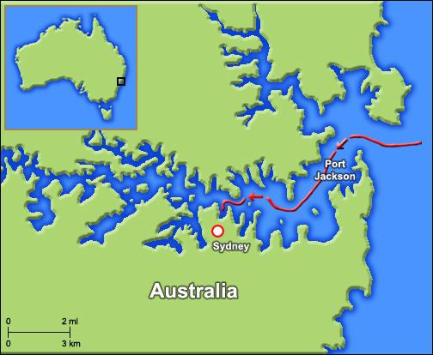
Sydney, Australia: 33oS 151oE
January 12, 1836
You arrive with the HMS Beagle in Sydney Cove, Australia. Sydney is a very lovely city, with
a population of approximately 23,000.

On this island continent, you and Mr. Darwin observe several unusual animal species, such
as:
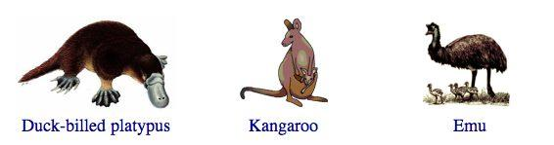
Mr. Darwin is so baffled by these unusual species that he has no other explanation for their
evolution other to assume that they must be a result of a totally separate act of creation!
A little bored by Darwin's immediate inability to explain where the bizarre species came
from, you decide to review your notes from your visit to South America. On a side trip to
the Isthmus of Panama, the land mass that divides the Caribbean Sea and the Pacific
Ocean, you joined Mr. Darwin as he obtained samples and studied several similar species
of snapping shrimp from both coasts of the isthmus. These crustaceans must have evolved
as a result of speciation - when new species arise from a single, existing species......but
how??
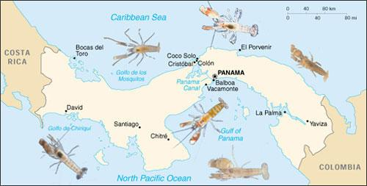

Cocos Islands: 12ºS 96ºE
April 1, 1836
We arrived in view of the Keeling or Cocos Islands, situated in the Indian Ocean., and about six hundred miles distant from the coast of Sumatra. This is one of the lagoon-islands of coral formation, similar to those in the Low Archipelago which we passed near....
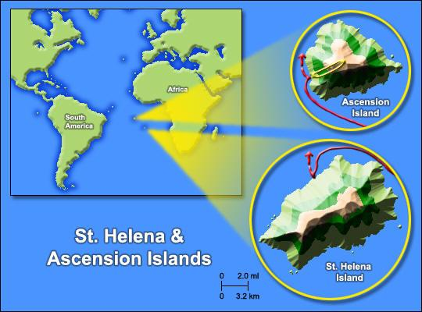
St. Helena
St. Helena, Acension : 20ºS 14ºW
July 8, 1836

On July 8, 1836 the HMS Beagle arrived on St. Helena. During this time, you stay by Charles Darwin's side as he observes populations of fish in different rivers and streams. Darwin is struck by the wide variation among the same species of fish from different streams, even among species living in different parts of the same stream. Darwin also observed differences in the distribution of the species' predators, and in the color and size of the gravel in different stream locations.
Darwin tells you as he begins to see a strong correlation between where fish lived in a particular stream and whether the fish were bright or drab in color. But what is responsible for these trends in coloration? And if bright colors made fish more conspicuous to predators, why should males be colorful at all?
http://www.pbs.org/wgbh/evolution/sex/guppy/
Welcome Home

Falmouth, England: 50ºN 5ºW
October 2, 1836
You, Charles Darwin and the crew of the HMS Beagle have finally returned home to England after four years, nine months and five days at sea! It was a long and tiring journey, but you learned a great deal about the factors that govern Charles Darwin's theory of evolution by natural selection.
By examining the evidence that Mr. Darwin used to support his theory, you have learned that living things have evolved, or changed over time, from an original ancestor. This evolution was guided by an organism’s survival requirements in their natural environment, a process that Darwin named natural selection. Natural selection states that members of a species that are best suited to their environment survive and reproduce at a higher rate than other members of the species. You took note as Darwin based this idea on the key principles that were evident throughout your voyage: overproduction, variation, adaptation and selection.

