Darwin’s Great Voyage of Discovery

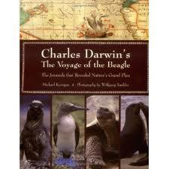
In 1831, at the time of Darwin’s voyage, travel was difficult and costly, and people seldom ventured far from their homes. Darwin, however, spent five years exploring the world. He set foot on many locations in the Southern hemisphere. As he traveled from place to place, Darwin was surprised, not by the differences between species, but by their similarities. He wrote in his journal of the Galapagos Islands, “..there is even a difference between the inhabitants of the different islands; yet all show a marked relationship with those of America, though separated from that continent by an open space of ocean, between 500 and 600 miles in width.” At this early stage in his life, soon after graduating from college, Darwin was already accumulating evidence and asking questions that would lead to his theory of natural selection. Follow in Darwin’s footsteps as he travels the world and changes from an amateur naturalist to a noted scientist.

Procedure:
Part A: Putting Darwin on the Map (Individual)

- Get a copy of the World Map, worksheet and excerpts from Darwin’s The Voyage of the Beagle. Each journal excerpt describes a location and includes a date and a latitude and longitude listing.

- Trace Darwin’s voyage by reading the excerpts. You will find that the journal excerpts are not in chronological order. The Voyage of the Beagle is a collection of many of Darwin’s journals, and he arranged the entries in this book by geographical area rather than by time.

- a. On your worksheet, list the excerpts in sequential time order by date, then fill in the columns for location as well as the longitude and latitude listings.

b. Use your worksheet to go in numerical and date order to find the locations on the world map of the places Darwin visited by using the longitude and latitude listings. When you have found the correct location, put the number by that location onto the map along with the date he visited it.

- Connect the excerpt locations (the numbers) with a dotted colored line. Start in England in 1831 and follow Darwin’s route until he arrived back in England in 1936.

Part B: Darwin’s observations lead to a theory.

- Carefully read through each observation. Take your time as the readings can be difficult to understand having been written almost 200 years ago.

- On your worksheet at each location of Darwin’s visit in the 1st column, summarize what Darwin saw in the 3rd column. (The 1st one’s been done for you.)

Part C: (Group)
Reread the entry for the Galapagos Islands. What did Darwin observe on these islands that he found puzzling? Think about what you’ve learned about adaptations and the environment and theorize what conclusion Darwin came to. Use the questions on the log sheet to help write a paragraph for each section(region) that Darwin visited.

Assessment:
Create a poster as a group including the following on it. A title about Darwin’s Journey. A map with a key that is correctly labeled and plotted. Pictures of organisms Darwin encountered on his Journey. Individual paragraph summaries of what Darwin learned at each region of his journey
Name: ____________________________ Date: _________________

Life Science Period: ________________

* | Take a Trip With  Charles Darwin  Log Sheet | *

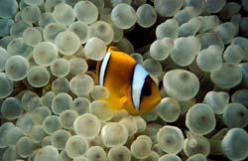
Santiago:
- Fish lay thousands of eggs in one reproductive cycle. What are some factors that prevent the majority of these eggs from developing into fish that then reproduce on their own?

- Overproduction obviously benefits the survival of fish species greatly. What could potentially happen to the survival of a fish species if their members do not produce eggs in such great quantities?

- What importance does overproduction play in Darwin’s theory of evolution by natural selection?

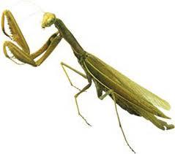
Salvador:

- What is the praying mantis’ strategy for self defense?

- The mantis is nearly invisible sitting on a leaf in the forest, but when the scientist places the insect on his blue shirt, it becomes very obvious. What does this suggest about how well this species of mantis would survive in a different environment -- a desert or a short-grass prairie, for example?

- Would an individual mantis be able to transform its appearance if it were placed in another type of environment? Why or why not?

- How does this praying mantis’ adaptation become common in the next generation?

_____________________________________________________________________

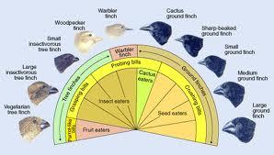
Galapagos Islands:

This diagram presents 10 species of finches on the Galapagos Islands, each filling a different niche on various islands. All of them evolved from one ancestral species, which colonized the islands only a few million years ago.

- Describe the types of variation you see in the illustrations of Darwin's finches.

- Why do you think each species' variation makes it well adapted to its physical environment?

- Why do you think each species' variation makes it well adapted for its food supply?

- How are the individual finches’ adaptations beneficial for their survival in their respective environments?

Australia:
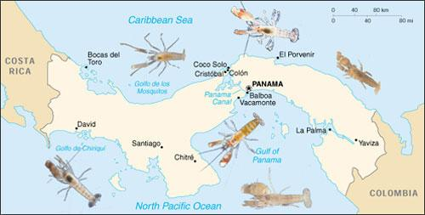
The Isthmus of Panama only arose some 3 million years ago. When the land mass was formed, this geological phenomenon produced a speciation event: Populations of snapping shrimp divided by the isthmus have diverged into separate species.

- How many different species of shrimp are currently found in the waters surrounding the Isthmus of Panama?

- Scientists today now know that an important factor in speciation is isolation – separation of population by a barrier. What physical barrier separated groups of snapping shrimp approximately 3 million years ago?

- Once isolated, the identical populations of shrimp began to evolve differently from one another. What factors may have caused these separated groups to physically change from their original parent species?

- What other animal (that you have already studied on your voyage) diverged into separate similar-looking species as a result of speciation?

____________________________________________
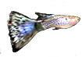

St. Helena:

There were two types of selection affecting the male guppie population – sexual (selection by the females for reproduction) and non-sexual (selection by the larger predatorial fish for food).
- How does sexual selection affect the appearance of male guppies?

- How does non-sexual natural selection affect the appearance of male guppies?

- Why might variation in guppy coloration have developed as a trait?

Group Work Expectations
Group project Subject Period Group members:
 | Rubric  2 (proficient)  1(partially proficient  0 (unsatisfactory) | Comment
Participation- Did everyone in the group participate equally, did everyone come prepared with their materials, was there active sharing of materials and information | 2 1 0
Listening to others- Open mindedness about others ideas, did everyone voice themselves, did your group - respectfully disagree or agree | 2 1 0
Distribution of responsibilities-The group breaks up responsibility of the tasks equitably, each person does the appropriate amount of work (no one person does it all) | 2 1 0
Support- Did everyone in the group support each other. If someone felt they were doing it all, did others make it equitable. Did others check on your progress | 2 1 0
Completion of Task- Did the task get completed and done done well | 2 1 0
Completion of individual responsibilities  Group Member #1  Group Member #2  Group Member #3  Group Member #4  Group Member #5  Group Member #6 | 2 1 0  2 1 0  2 1 0  2 1 0  2 1 0  2 1 0
How does the whole group rate each individual member  Group Member #1  Group Member #2  Group Member #3  Group Member #4  Group Member #5  Group Member #6 | 2 1 0  2 1 0  2 1 0  2 1 0  2 1 0  2 1 0

Darwin’s Journey  Individual Worksheet with summaries and Maps  Student shows exceptional effort put into plotting Darwin’s journey on their map, and summarizing what he earned at each location.  Group Rubric Score  The total score for each student based on the group rubric.  Presentation  The poster shows a strong understanding of Darwin’s Voyage. The following elements were in the poster. A title, a clean map with Darwin’s locations and plotted correctly, summary paragraphs of what Darwin learned at each location for each group member, color, neatness, pictures  Total | ____/8pts  ___/14pts  ____/10pts  ___/32pts | Darwin’s Journey  Individual Worksheet with summaries and Maps  Student shows exceptional effort put into plotting Darwin’s journey on their map, and summarizing what he earned at each location.  Group Rubric Score  The total score for each student based on the group rubric.  Presentation  The poster shows a strong understanding of Darwin’s Voyage. The following elements were in the poster. A title, a clean map with Darwin’s locations and plotted correctly, summary paragraphs of what Darwin learned at each location for each group member, color, neatness, pictures  Total | ____/8pts  ___/14pts  ____/10pts  ___/32pts
Darwin’s Journeyy  Individual Worksheet with summaries and Maps  Student shows exceptional effort put into plotting Darwin’s journey on their map, and summarizing what he earned at each location.  Group Rubric Score  The total score for each student based on the group rubric.  Presentation  The poster shows a strong understanding of Darwin’s Voyage. The following elements were in the poster. A title, a clean map with Darwin’s locations and plotted correctly, summary paragraphs of what Darwin learned at each location for each group member, color, neatness, pictures  Total | ____/8pts  ___/14pts  ____/10pts  ___/32pts | Darwin’s Journey  Individual Worksheet with summaries and Maps  Student shows exceptional effort put into plotting Darwin’s journey on their map, and summarizing what he earned at each location.  Group Rubric Score  The total score for each student based on the group rubric.  Presentation  The poster shows a strong understanding of Darwin’s Voyage. The following elements were in the poster. A title, a clean map with Darwin’s locations and plotted correctly, summary paragraphs of what Darwin learned at each location for each group member, color, neatness, pictures  Total | ____/8pts  ___/14pts  ____/10pts  ___/32pts

