History of the Earth Pre-Test
Name: _________________________________________________ Class: _______________
- How old is the Earth?
  - 2 million years c. 4 million years
  - 2.5 billion years d. 4.6 billion years
- The law of superposition states that
  - The youngest is on the bottom c. oldest is on the bottom
  - The oldest is on the top d. the rock that cuts across is older
- What era is known as the age of the dinosaurs?
  - Cenezoic c. Paleozoic
  - Mesozoic d. Precambrian
- What era is known as the “age of mammals”?
  - Cenezoic c. Paleozoic
  - Mesozoic d. Precambrian
- In what era did the “Explosion of Life” begin into the oceans?
  - Cenezoic c. Paleozoic
  - Mesozoic d. Precambrian
- What two techniques can scientists use to determine the age of a rock or a fossil?
- General Relativity & Law of Reflection c. rock sequencing & absolute dating
- Relative Dating & Absolute Dating d. relative fossils & radiometric rocks
- Which era/eon in the Geologic Time Scale represents the largest expanse of time?
  - Precambrian c. paleozoic
  - Cenozoic d. mesozoic
- The law of cross cutting relationships states that
  - The rock that cuts across is older than the rock it cuts
  - The rock that cuts across is younger than the rock it cuts
  - The rock that cuts across is the same age as the rock it cuts
  - The rock that is being cut is younger than the rock that is cutting it
- Index fossils are fossils that are found
  - In only one rock layer c. in the oldest rock layer
  - In all rock layers d. in the youngest rock layer
- The era that we live in today is called the
  - Mesozoic c. Triassic
  - Paleozoic d. Cenezoic
- What type of rock would form deep within the Earth from heat and pressure?
  - Sedimentary c. metamorphic
  - Igneous d. limestone
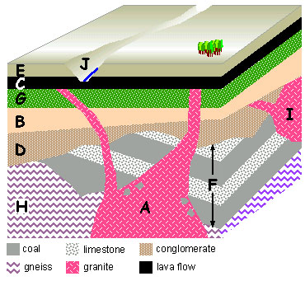
- What is A? ________________
- What does A turn into? _________
- In which layer would you find a metamorphic rock? ____________
- In which layer would you find an igneous rock? ______________
- In which layer(s) would you find a sedimentary rock? _____________
- List the order of rocks from oldest to youngest.
Extended Response Questions
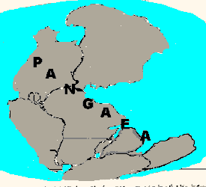

- The Earth has changed greatly during its 4.6 billion year history.
- Chose an Era and explain in detail 3 events/descriptions that characterized that time period in the Earth’s history.

